Course Project

Weekly Update Date: 5/20/2022

Team Members: Peiqi Wu; Yuzhen Zhou

Answer to Individual Questions:

(100 points total, all questions weighted equally)

● Assumptions provided when required

Total in points (100 points total): ___________________

Professor’s Comments:

Peiqi Wu

Yuzhen Zhou

Prof. Franchitti

Cloud Computing

GitHub Repo: <https://github.com/ElioZhou/ArchNav-Cloud-Migration>

Final Project Report Part1

Cloud migration is the process of moving a company’s digital assets, services, databases, IT resources, and applications either partially, or wholly, into the cloud. Cloud migration is also about moving from one cloud to another.

The cloudification of the Archemy Archnav Application involves 4 major components. These components are an ApacheDS server to house the LDAP data, a Tomcat server that contains the Fortress-Web and Fortress-REST components, a Glassfish server to deploy the archemy.ear application and lastly a MySQL server. A combination of platforms may be used to move the application to Cloud. AWS is being considered in the following.

All the detailed README, migration steps as well as the required codes can be count at:

<https://github.com/ElioZhou/ArchNav-Cloud-Migration>

**MySQL Database preparation:**

The first thing need to deal with is the preparation of ArchNav database.

Import the ArchNav Stored Procedures:

Go to “~\App\ArchemyAppModel\src\com\archemy\searchapp\model\sql\” and open the procedures.sql file in the MySQL Workbench and Execute the file

Import the ArchNav Data:

To import the ArchNav database data navigate to the Data sub-directory. Load the DatabaseImport.sql file into the MySQL Workbench and run the script.

We followed the installationGuide and successfully created the ArchNav Database on our local machine using the MySQL Workbench, as the following:

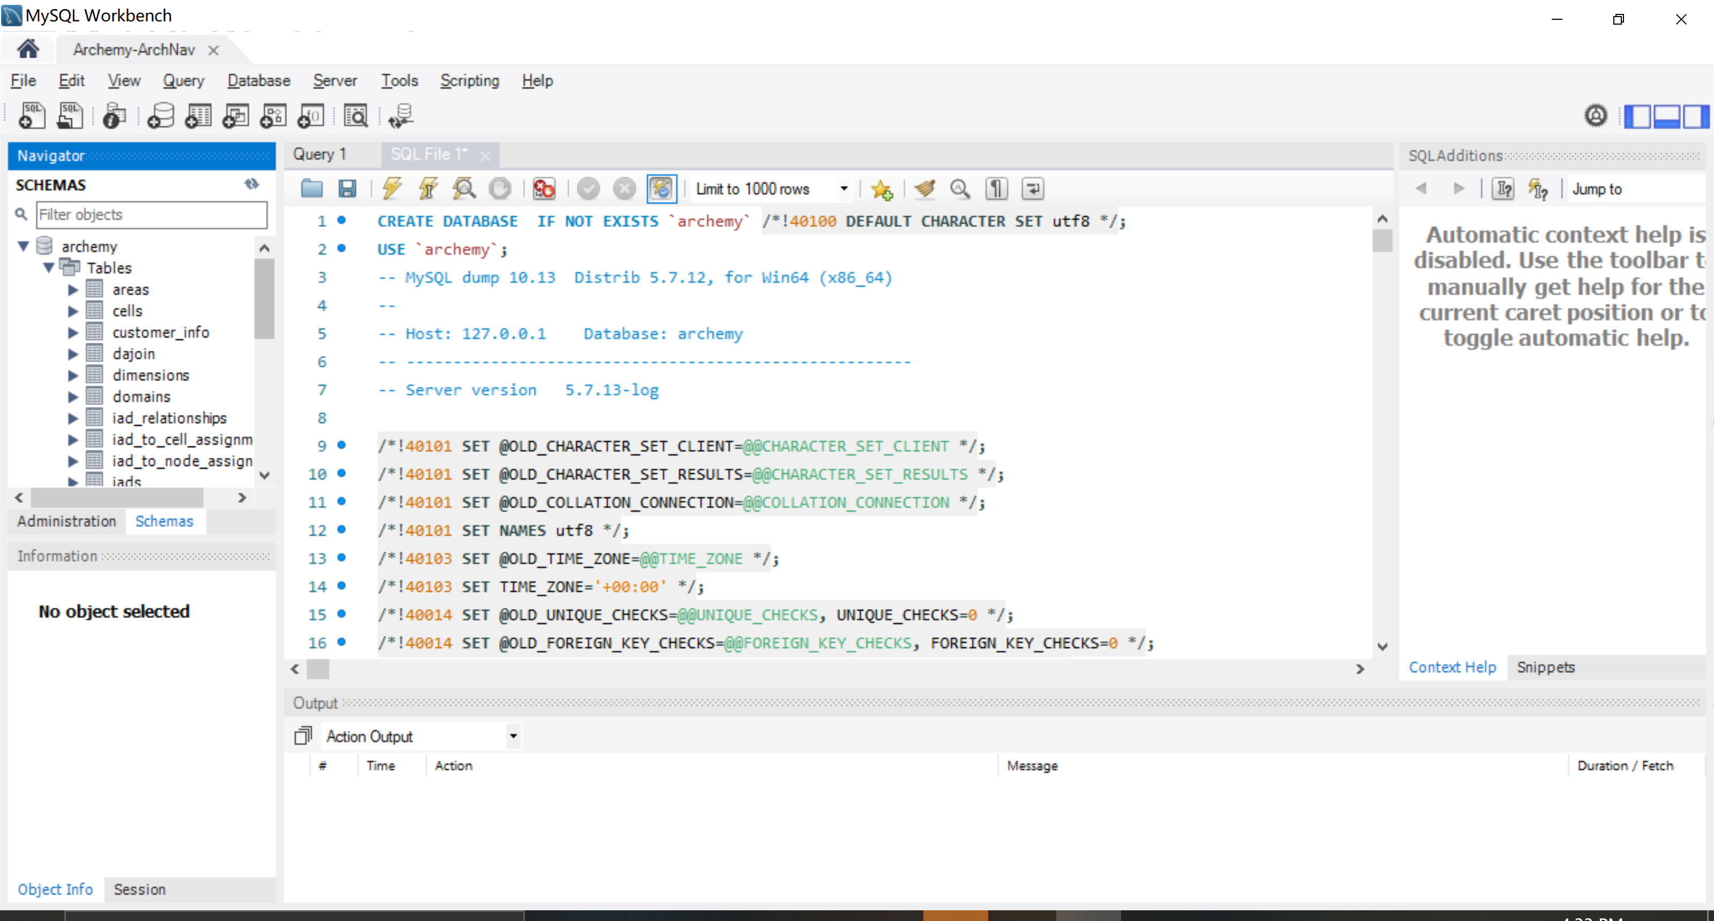

However, if we want to use MySQL on the virtual machine, we have to use command line operation, so as <https://phoenixnap.com/kb/mysql-docker-container> writes, we deployed MySQL container using AWS RDS:

database-1.c0lbmcgortx1.us-east-1.rds.amazonaws.com

port: 3306

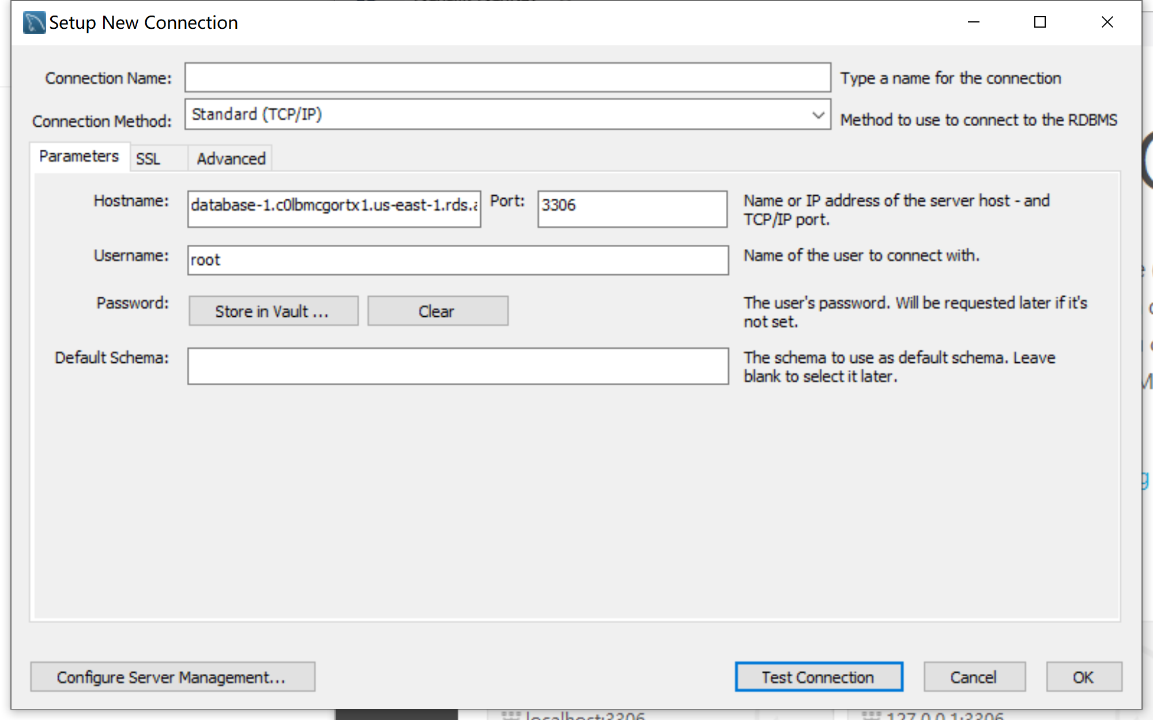

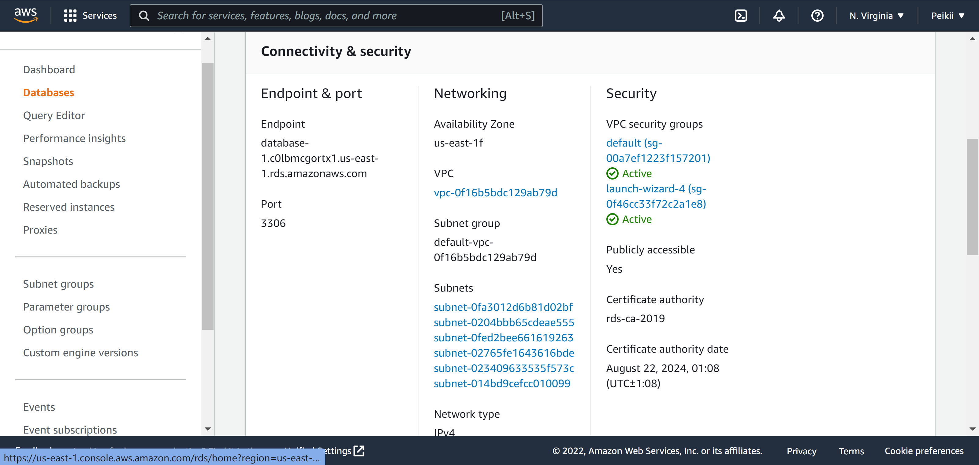

And then we can connect the database to the AWS cloud.

**ApacheDS Server component and Fortress Web components:**

To see the detailed operation steps, please go to our git repository: <https://github.com/ElioZhou/ArchNav-Cloud-Migration/tree/master/Fotress>

The ApacheDS service can easily be run in a Docker container by using the stock docker Image for ApacheDS.

To prepare ApacheDS environment ready:

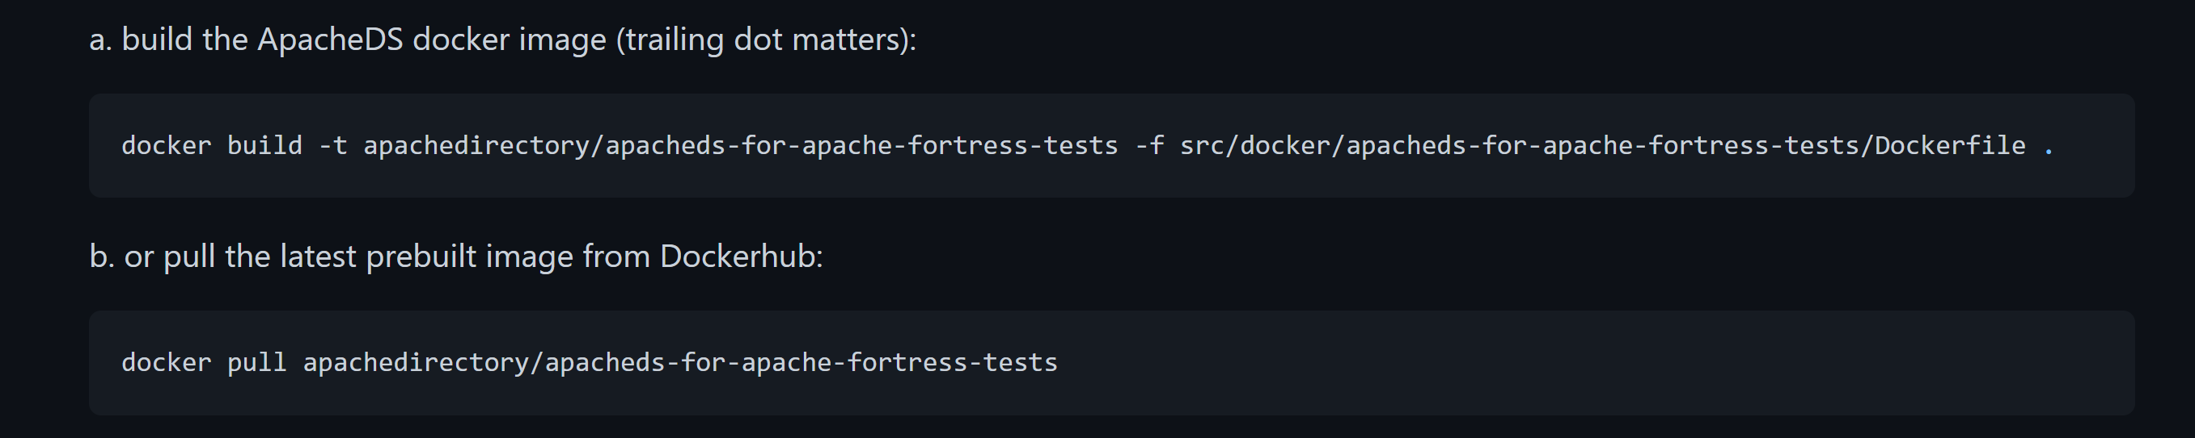

Run the ApacheDS docker image:

docker run --name=apacheds -d -p 10389:10389 -P apachedirectory/apacheds-for-apache-fortress-tests

Verify the image started successfully:

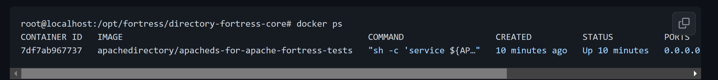

We also need to get Apache Fortress Core package:

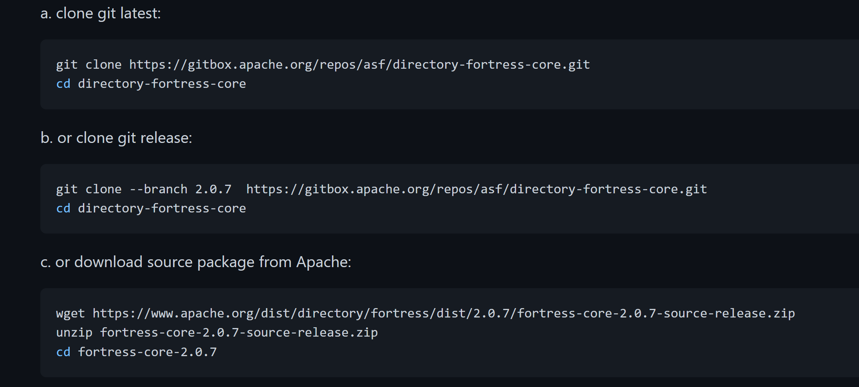

After the preparations of the environment have been set, we set up Apache Fortress:

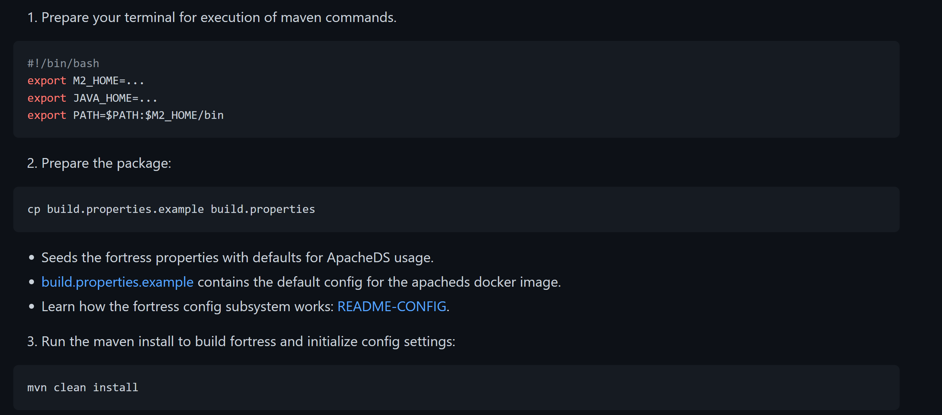

Then we do the Apache Fortress Core Integration Test:

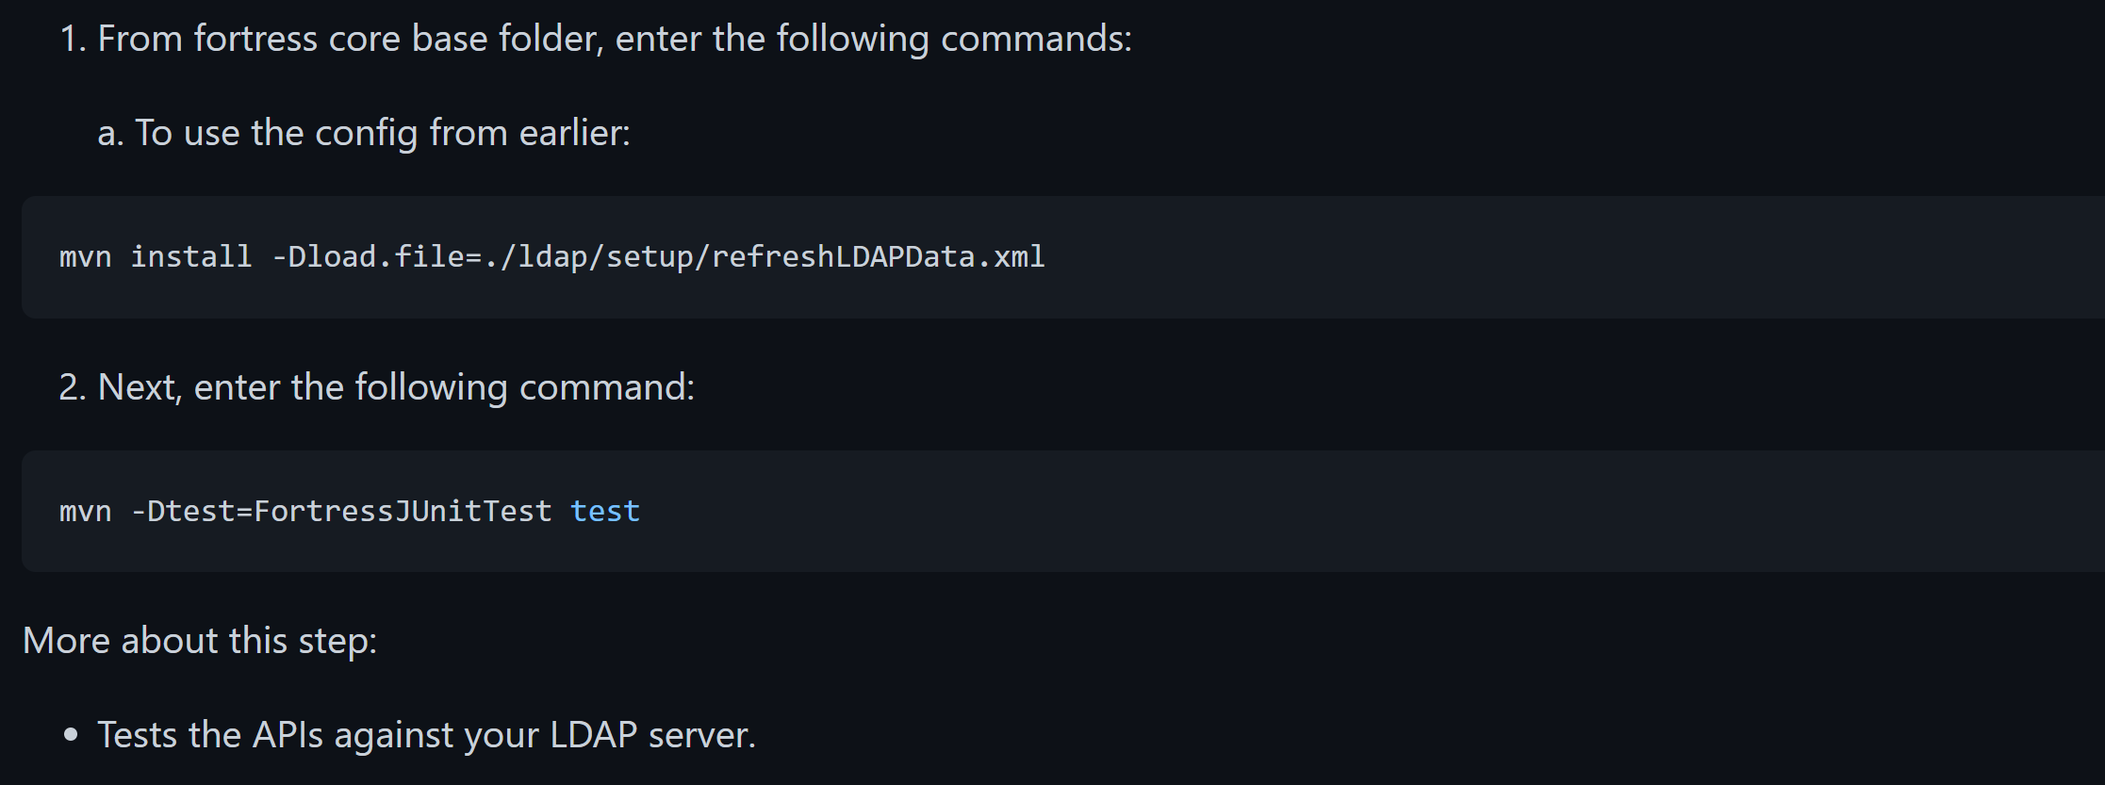

Check the work to verify the test:

NUMBER OF ADDS: 1146

NUMBER OF BINDS: 1130

NUMBER OF DELETES: 0

NUMBER OF MODS: 4247

NUMBER OF READS: 20176

NUMBER OF SEARCHES: 7045

Tests run: 128, Failures: 0, Errors: 0, Skipped: 0, Time elapsed: 335.906 sec - in org.apache.directory.fortress.core.impl.FortressJUnitTest

Results :

Tests run: 128, Failures: 0, Errors: 0, Skipped: 0

[INFO]

[INFO] --- maven-antrun-plugin:1.8:run (fortress-load) @ fortress-core ---

[INFO] Executing tasks

fortress-load:

[INFO] Executed tasks

[INFO]

[INFO] --- maven-antrun-plugin:1.8:run (fortress-load-debug) @ fortress-core ---

[INFO] Executing tasks

fortress-load-debug:

[INFO] Executed tasks

[INFO] ------------------------------------------------------------------------

[INFO] BUILD SUCCESS

[INFO] ------------------------------------------------------------------------

[INFO] Total time: 05:58 min

[INFO] Finished at: 2022-01-02T15:23:11Z

[INFO] ------------------------------------------------------------------------

Apache Fortress Rest Setup:

<https://github.com/ElioZhou/ArchNav-Cloud-Migration/tree/master/Fotress#section-6-apache-fortress-rest-setup>

Apache Fortress Web Setup:

<https://github.com/ElioZhou/ArchNav-Cloud-Migration/tree/master/Fotress#section-7-apache-fortress-web-setup>

**Tomcat Web Server Result:**

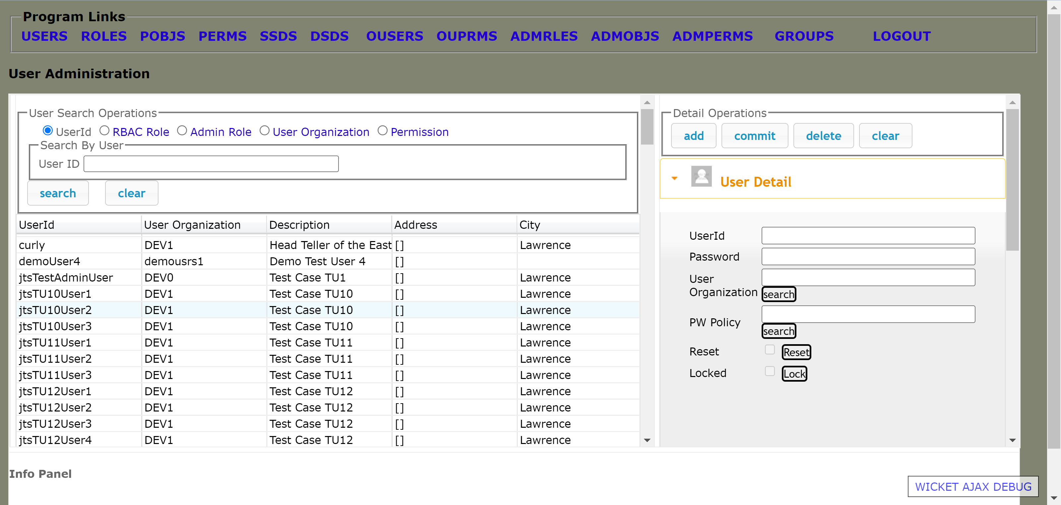

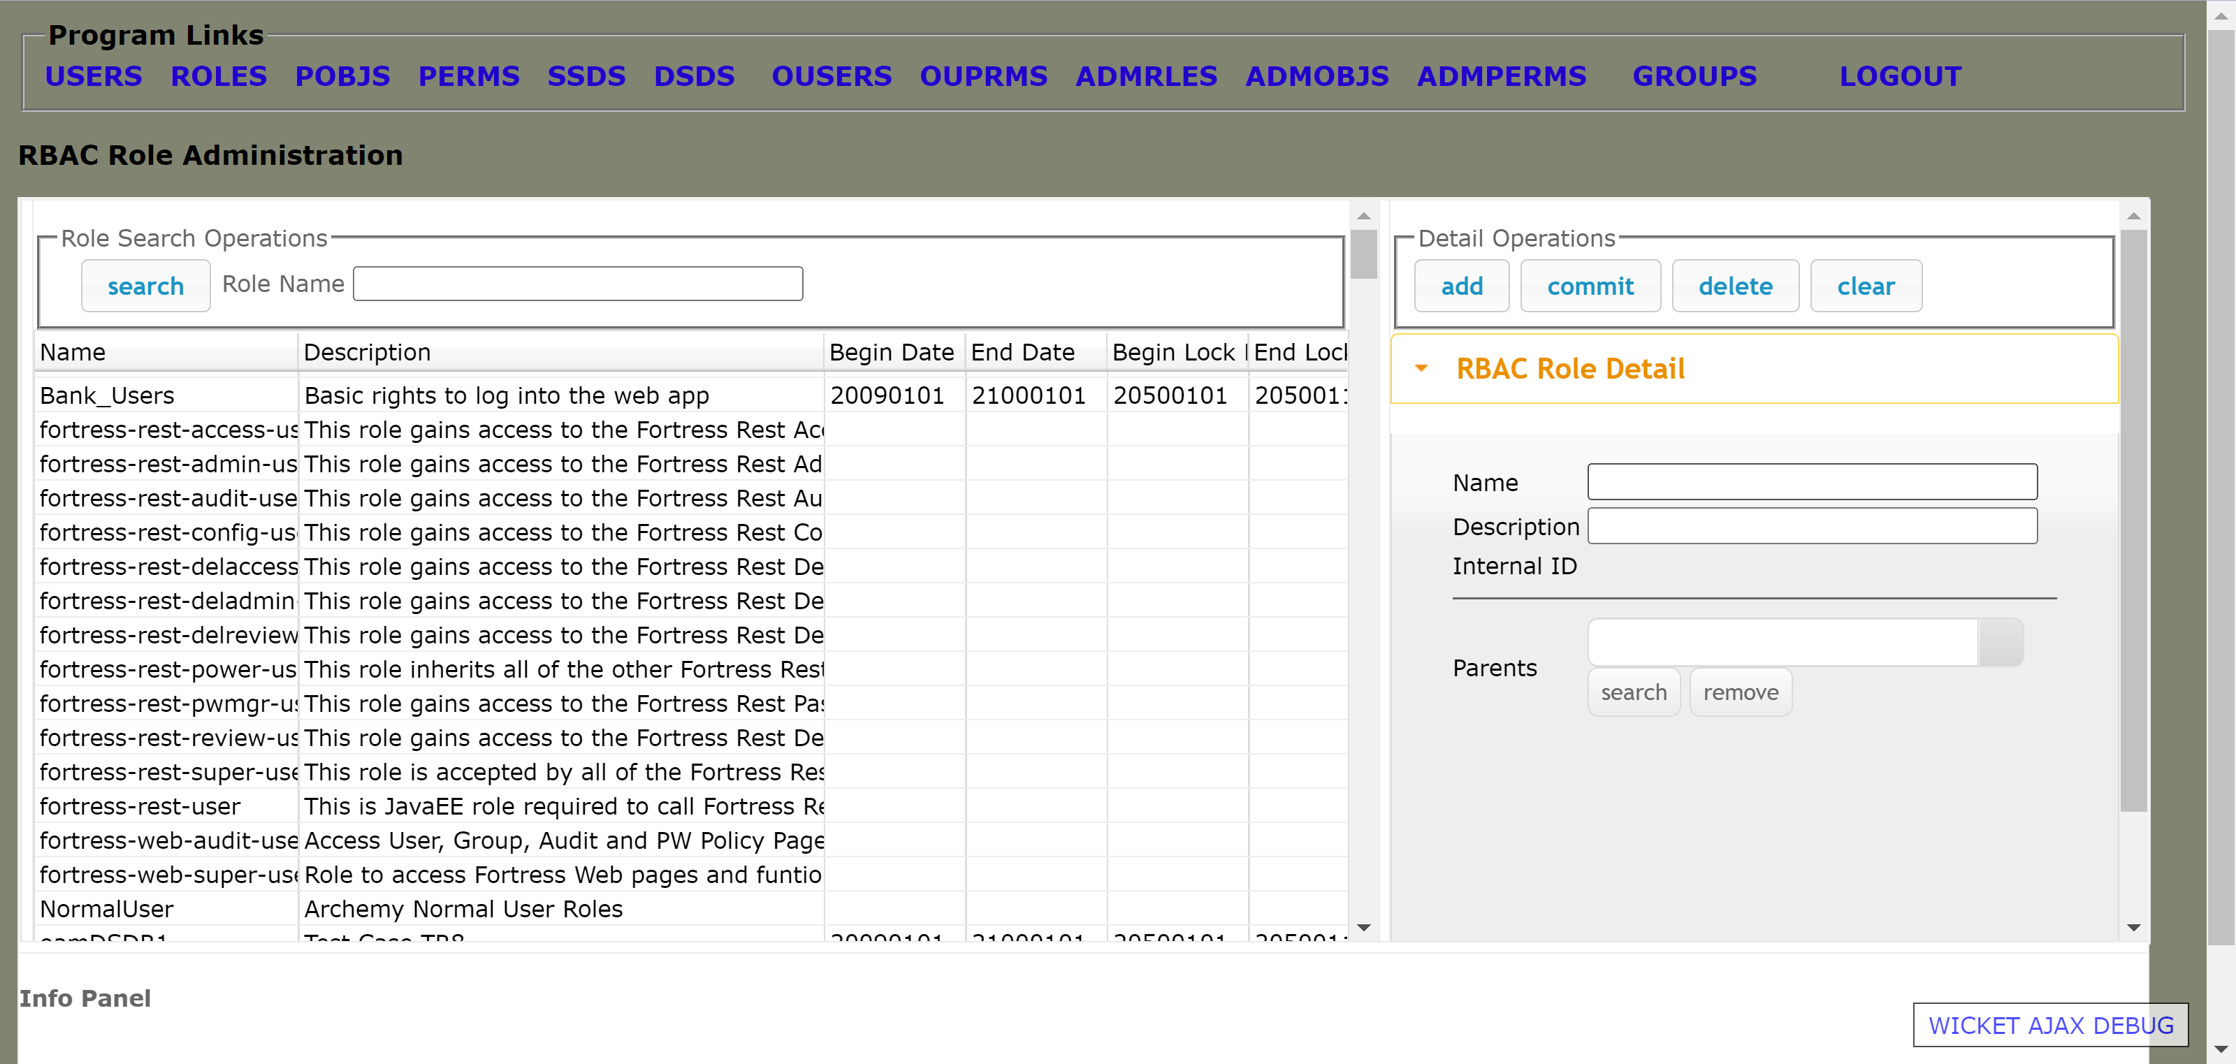

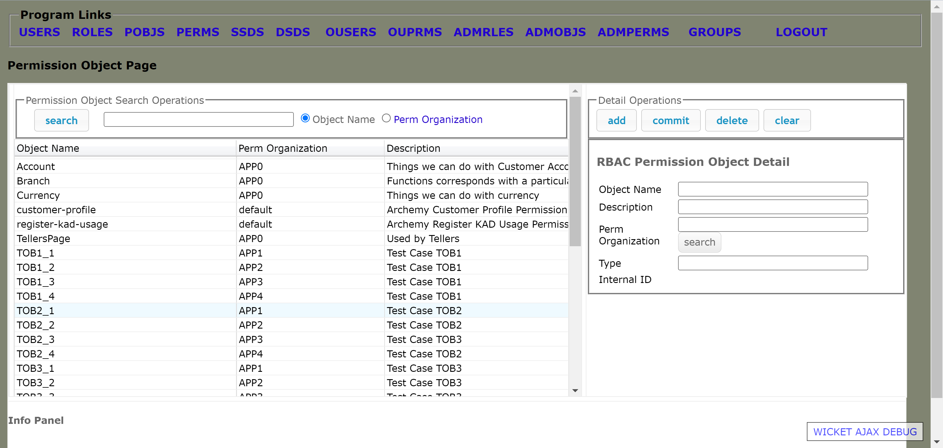

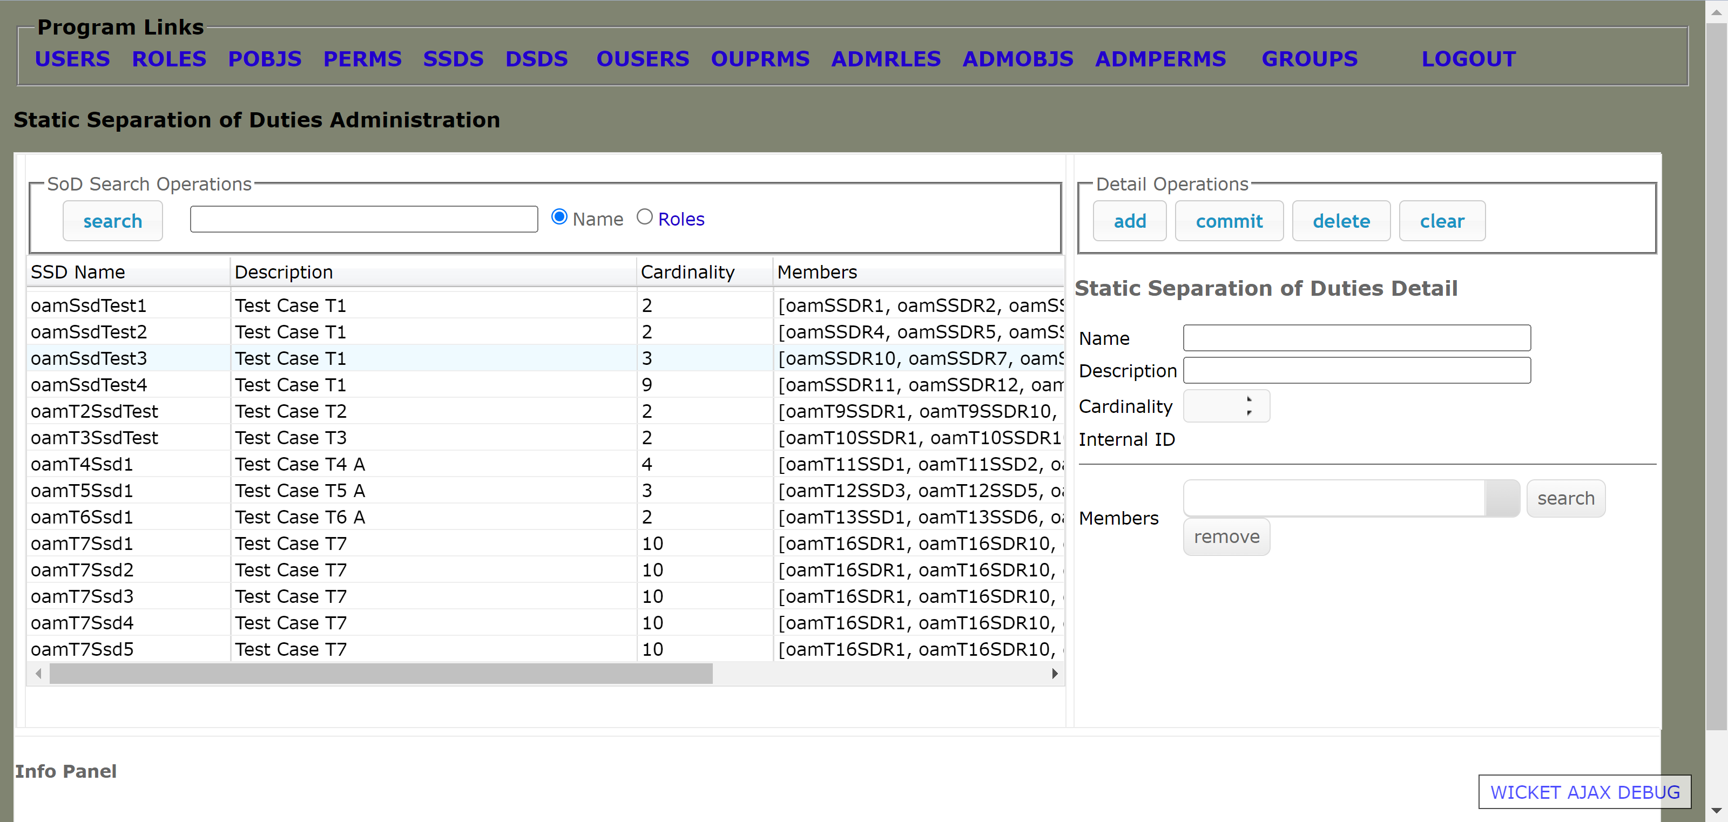

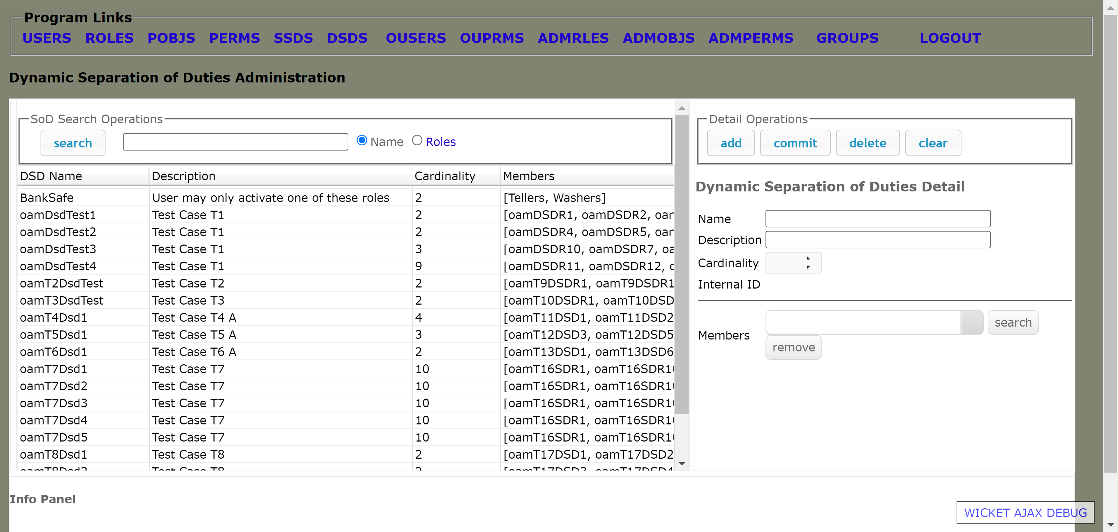

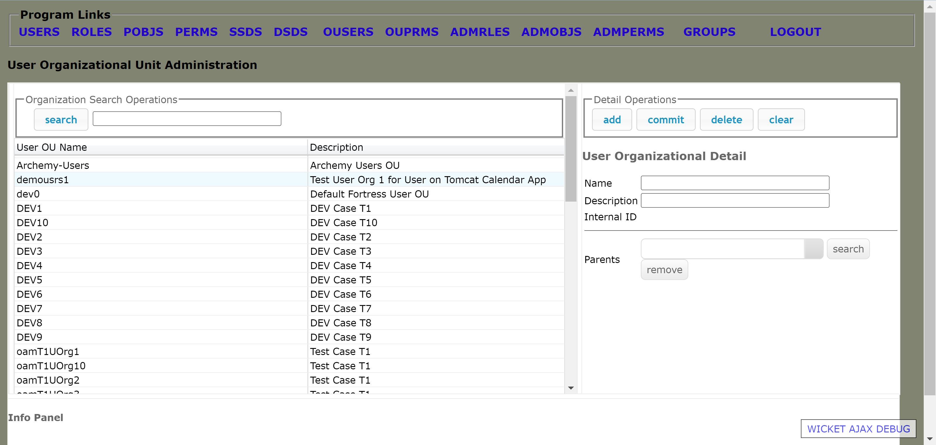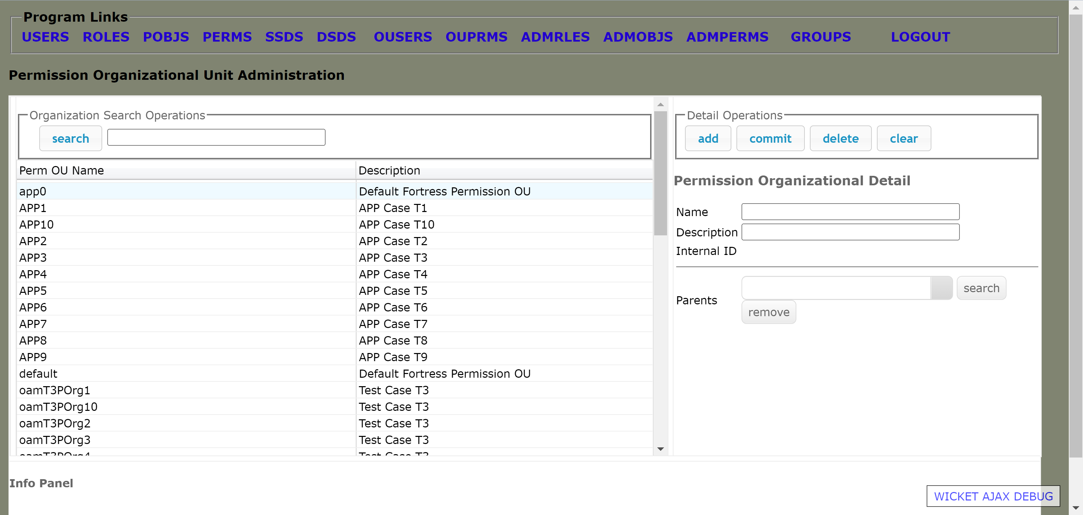

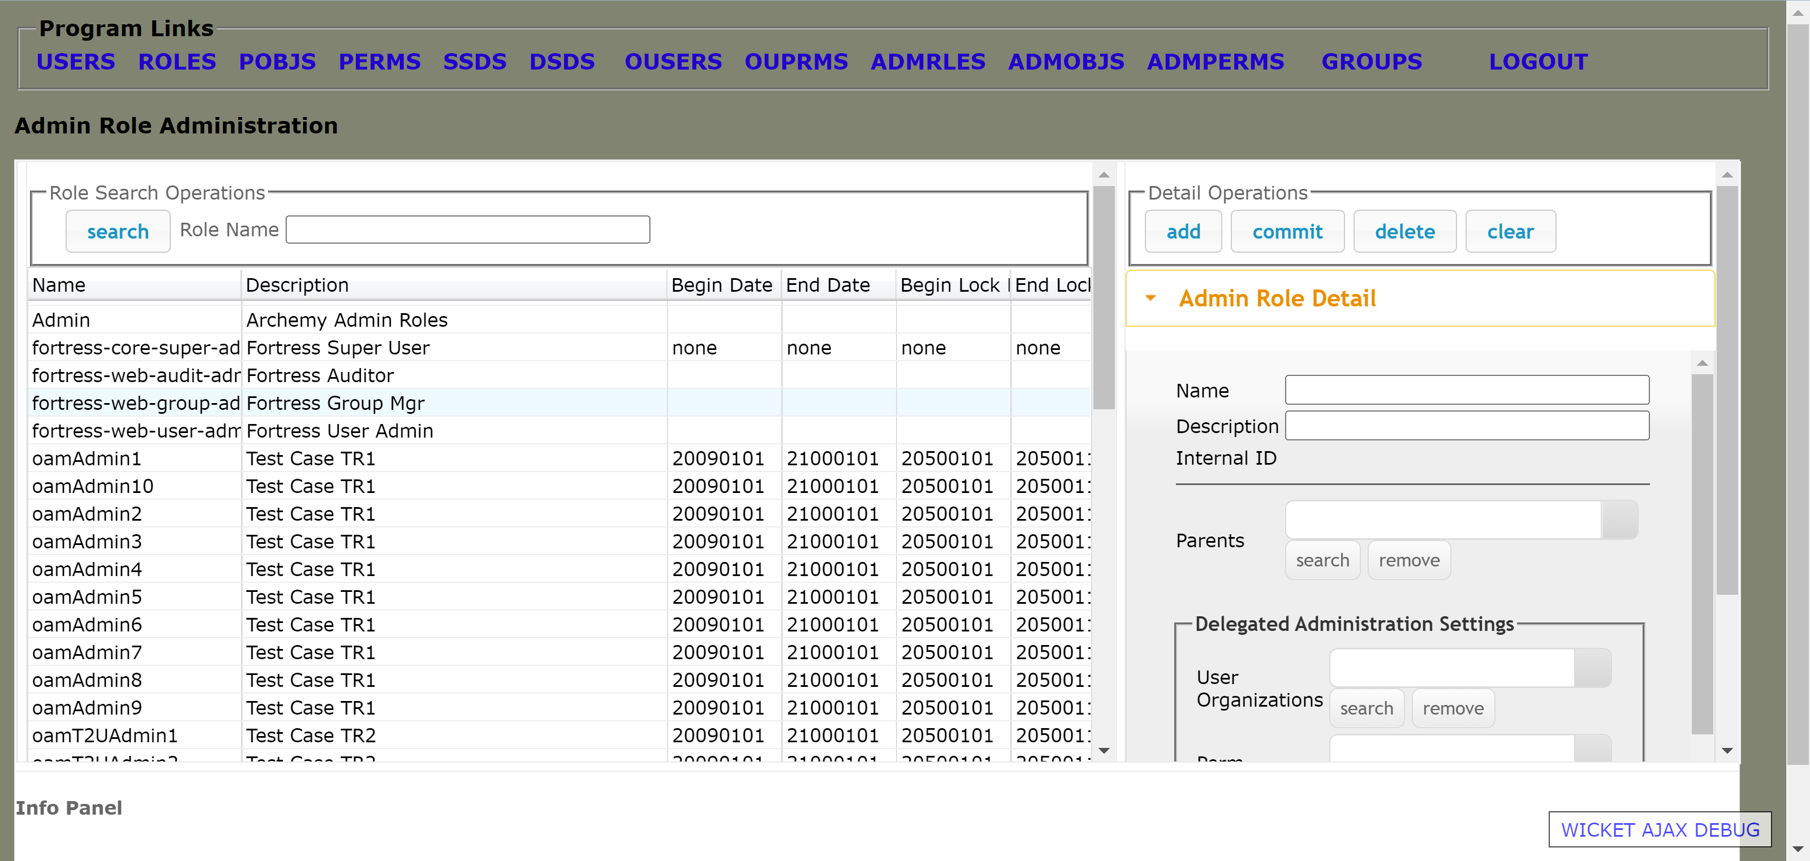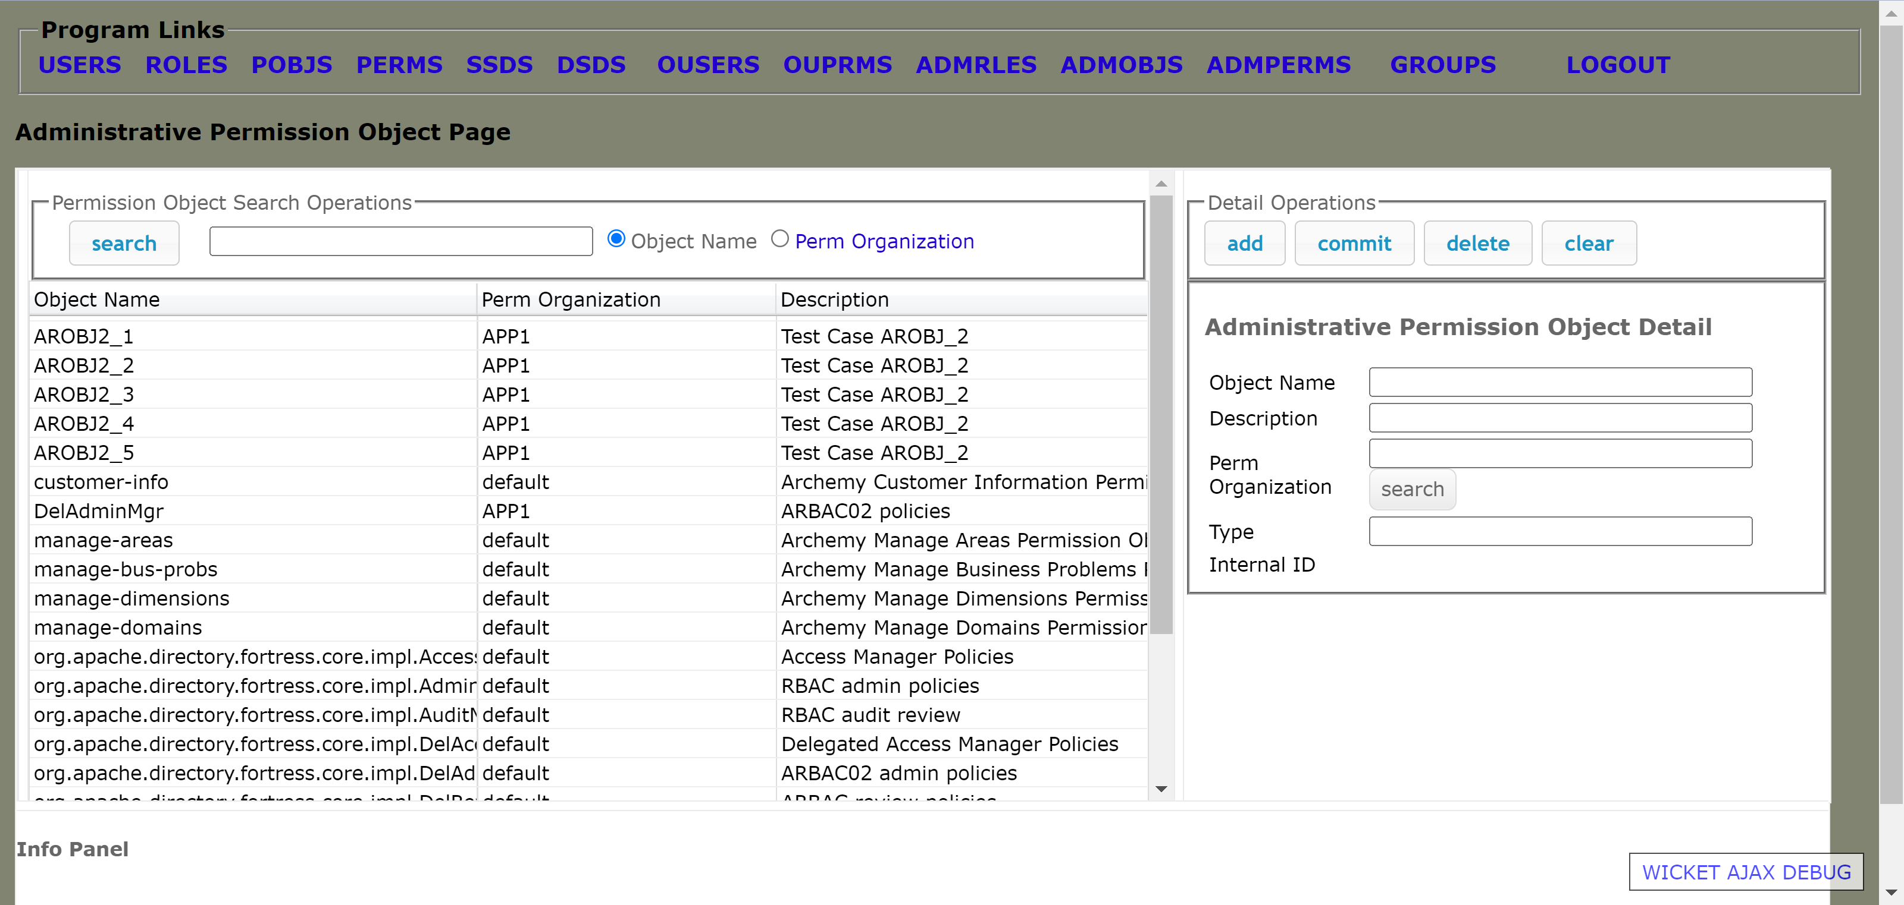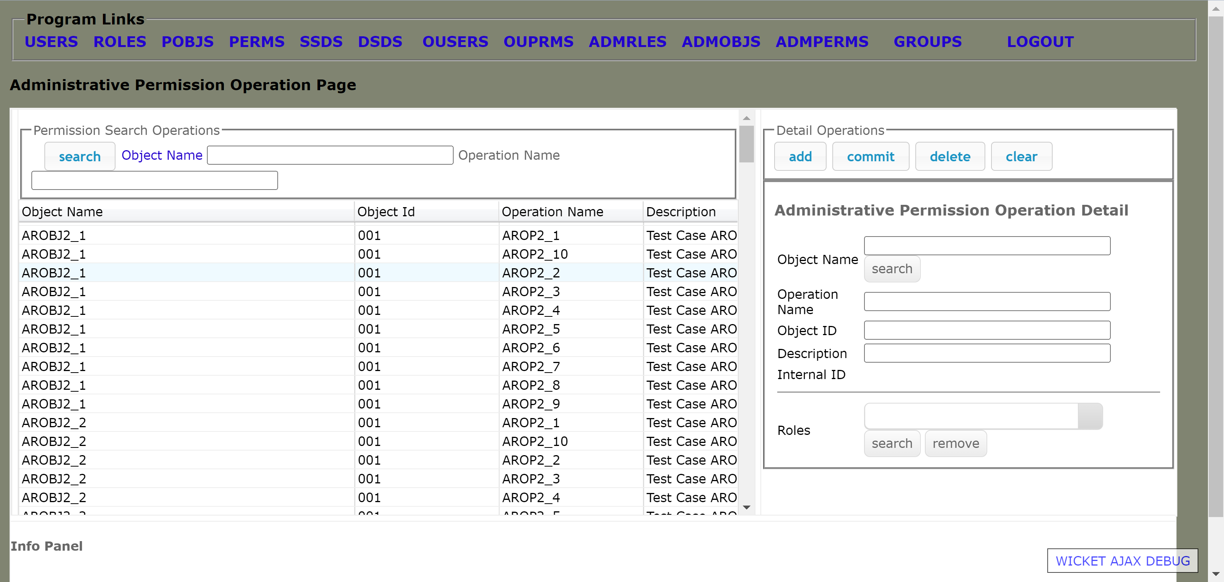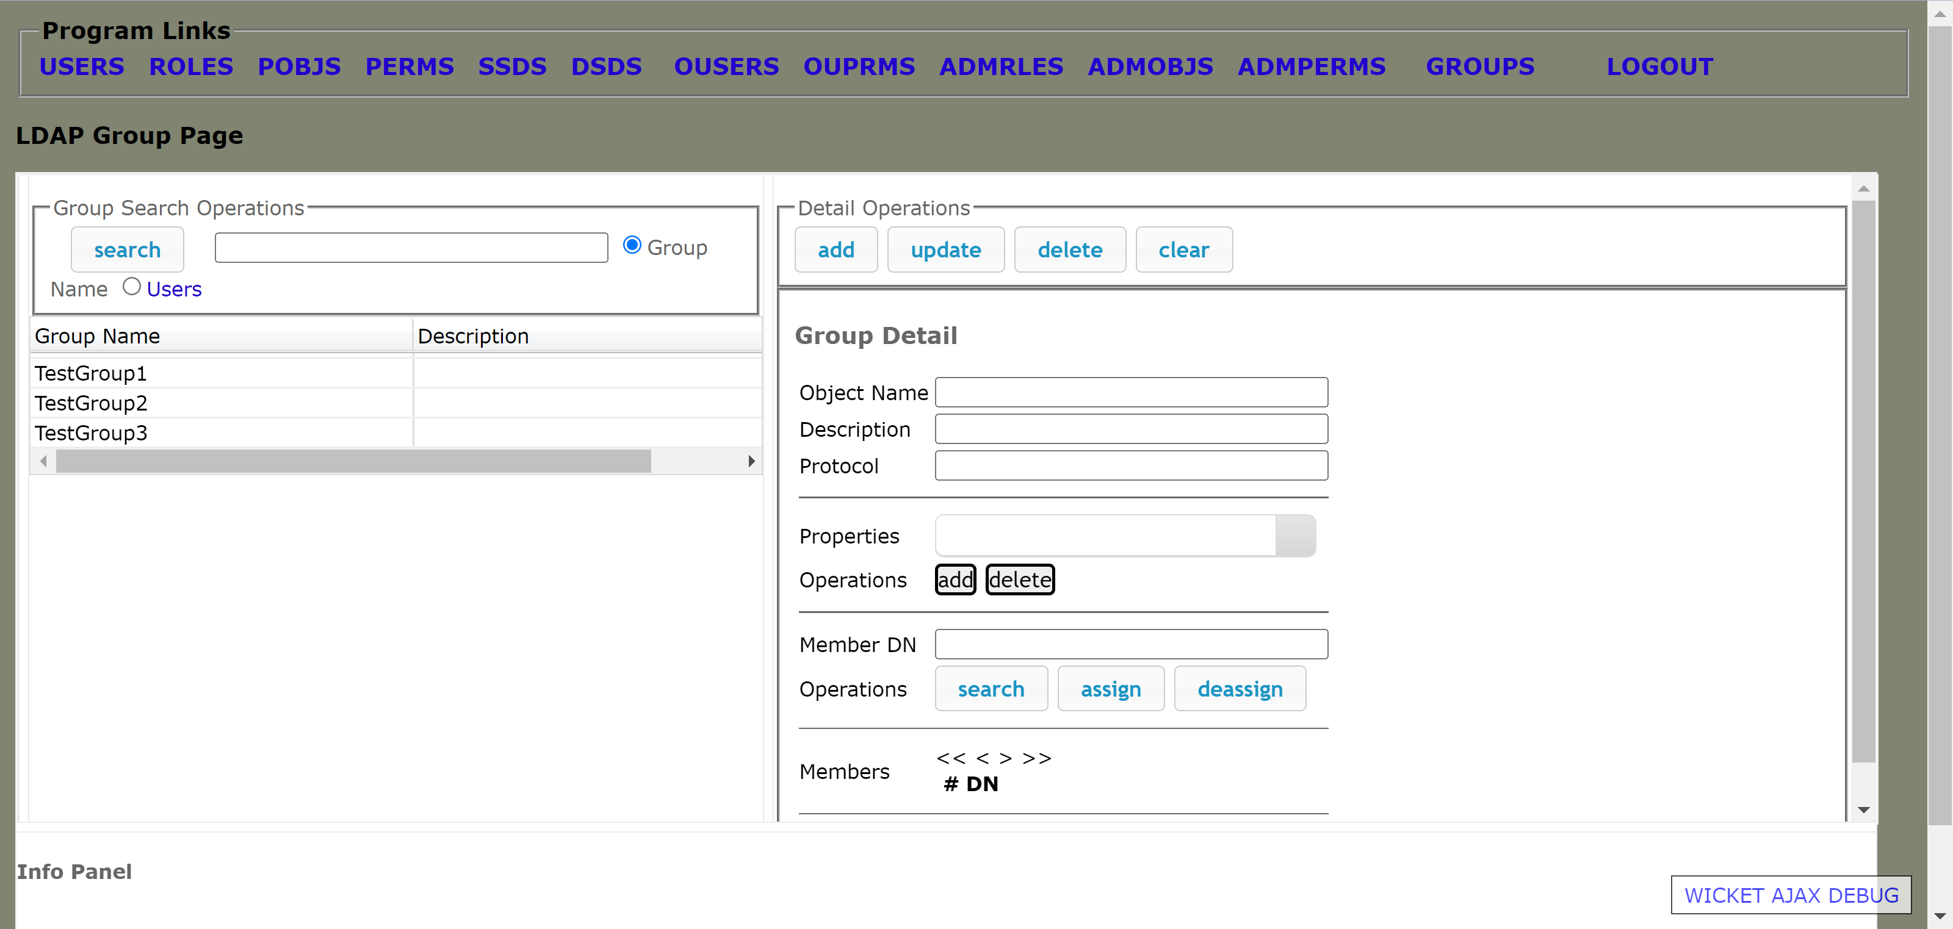

**Archemy.ear deployment on Glassfish 5.0:**

To see the full details, please refer to our git repository:

<https://github.com/ElioZhou/ArchNav-Cloud-Migration/tree/master/glassfish>

Build Archemy.ear:

Using JDeveloper to load Archemy.jws workspace

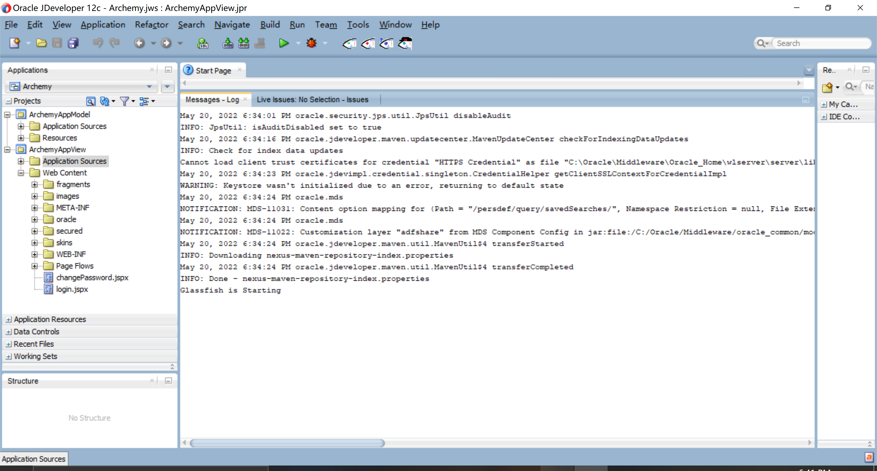

Separately configure ArchemyAppView Application Properties and Project Properties:

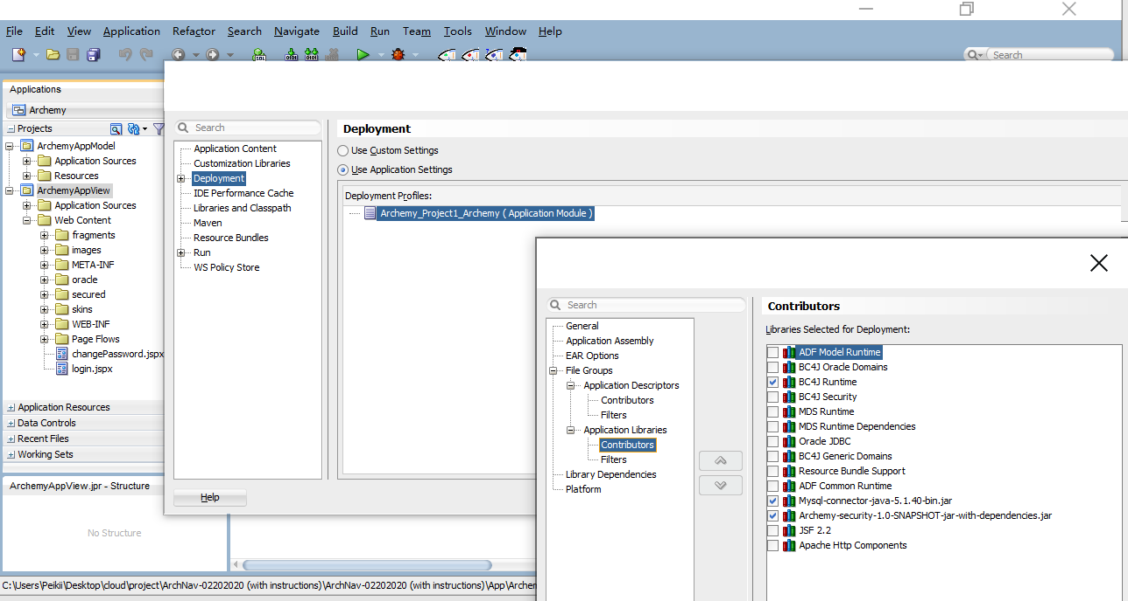

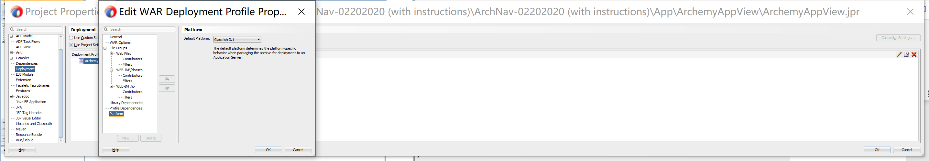

Finally deploy the project as .ear file:

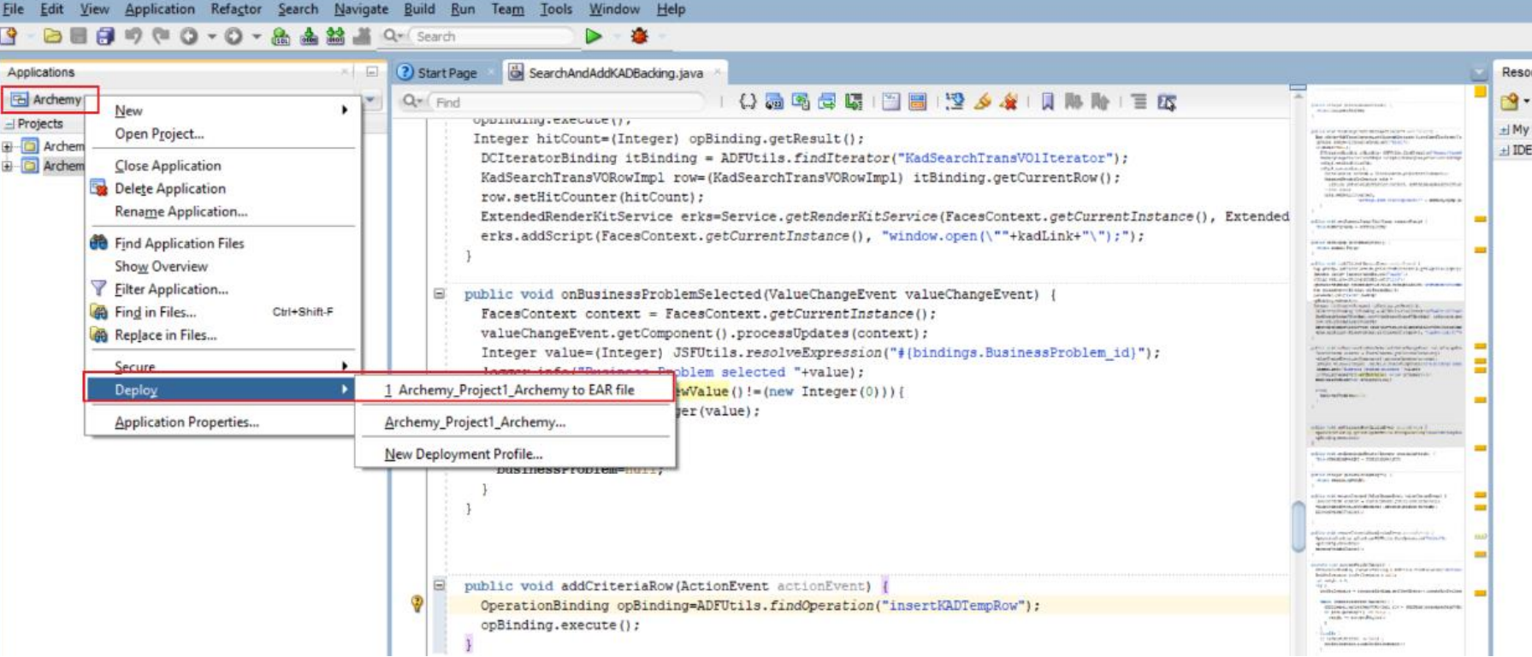

The first thing we have to do is preparing glassfish5 ready for our virtual machine.

Try:



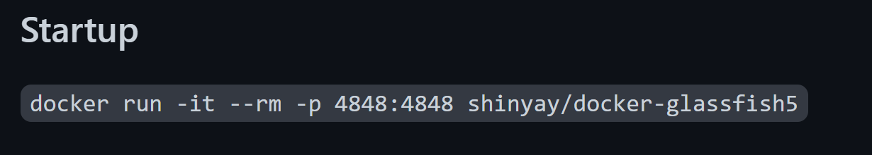

To access your Glassfish server, go to <https://your-ip-address:4848>

User:admin

Password:glassfish

Here is the Demo of the docker step:



Here is the glassfish server GUI:

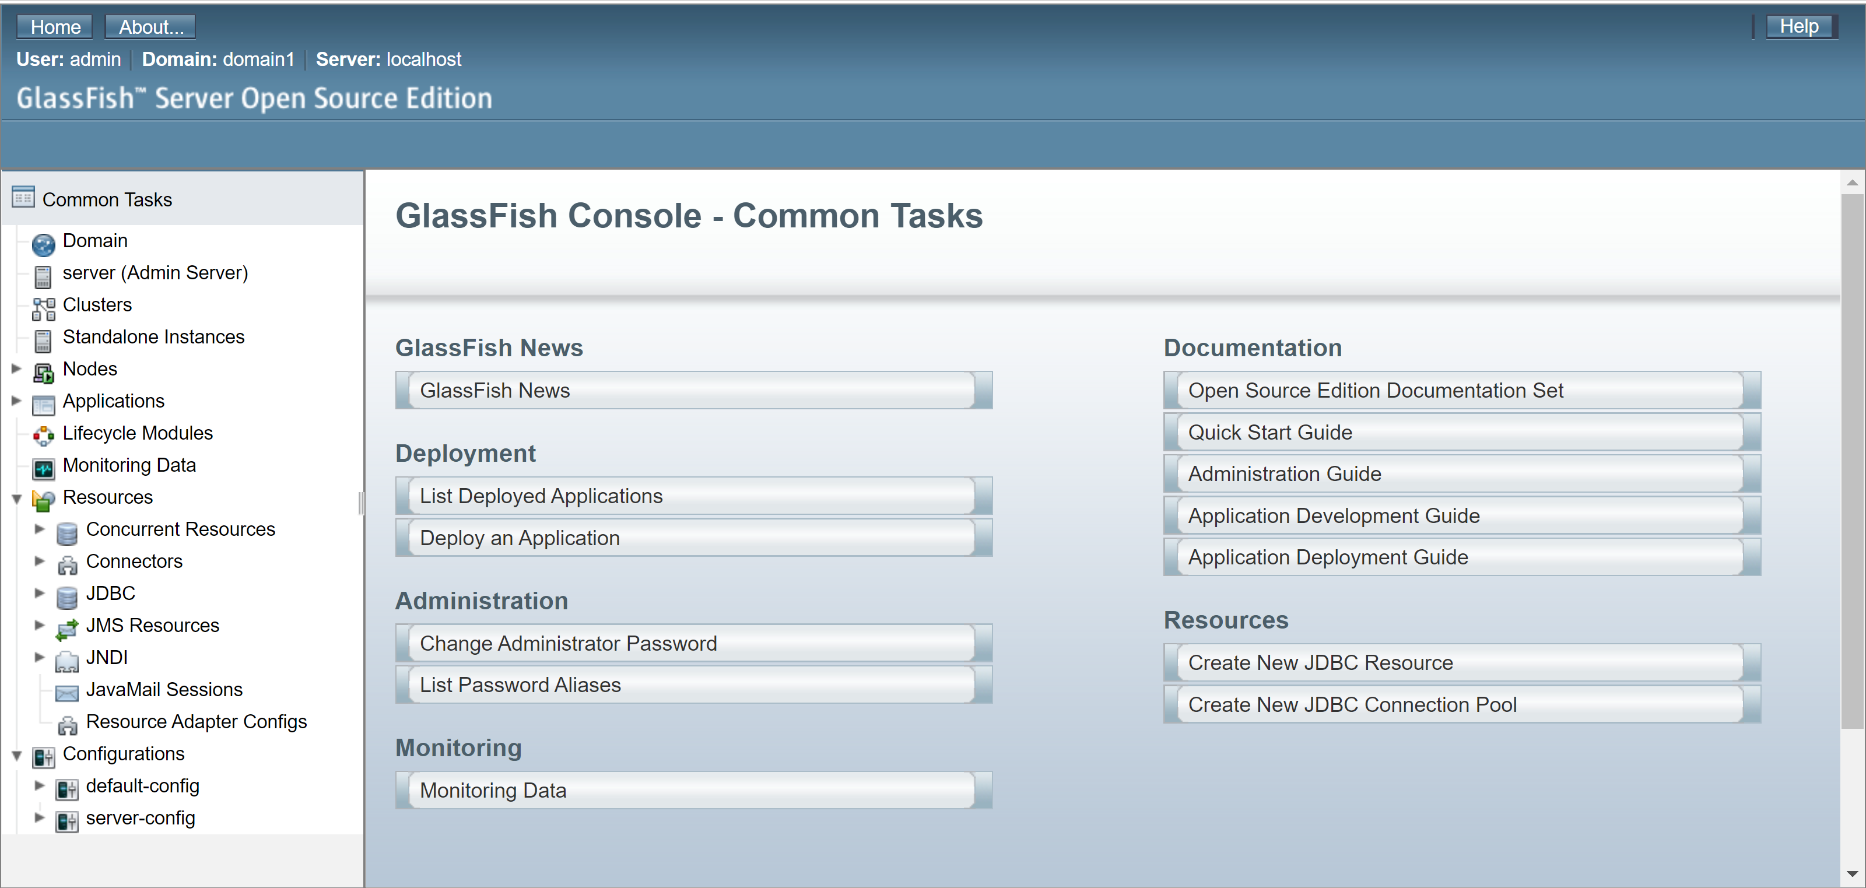

Then we click the Application on the left panel and upload the .ear file which we generated:

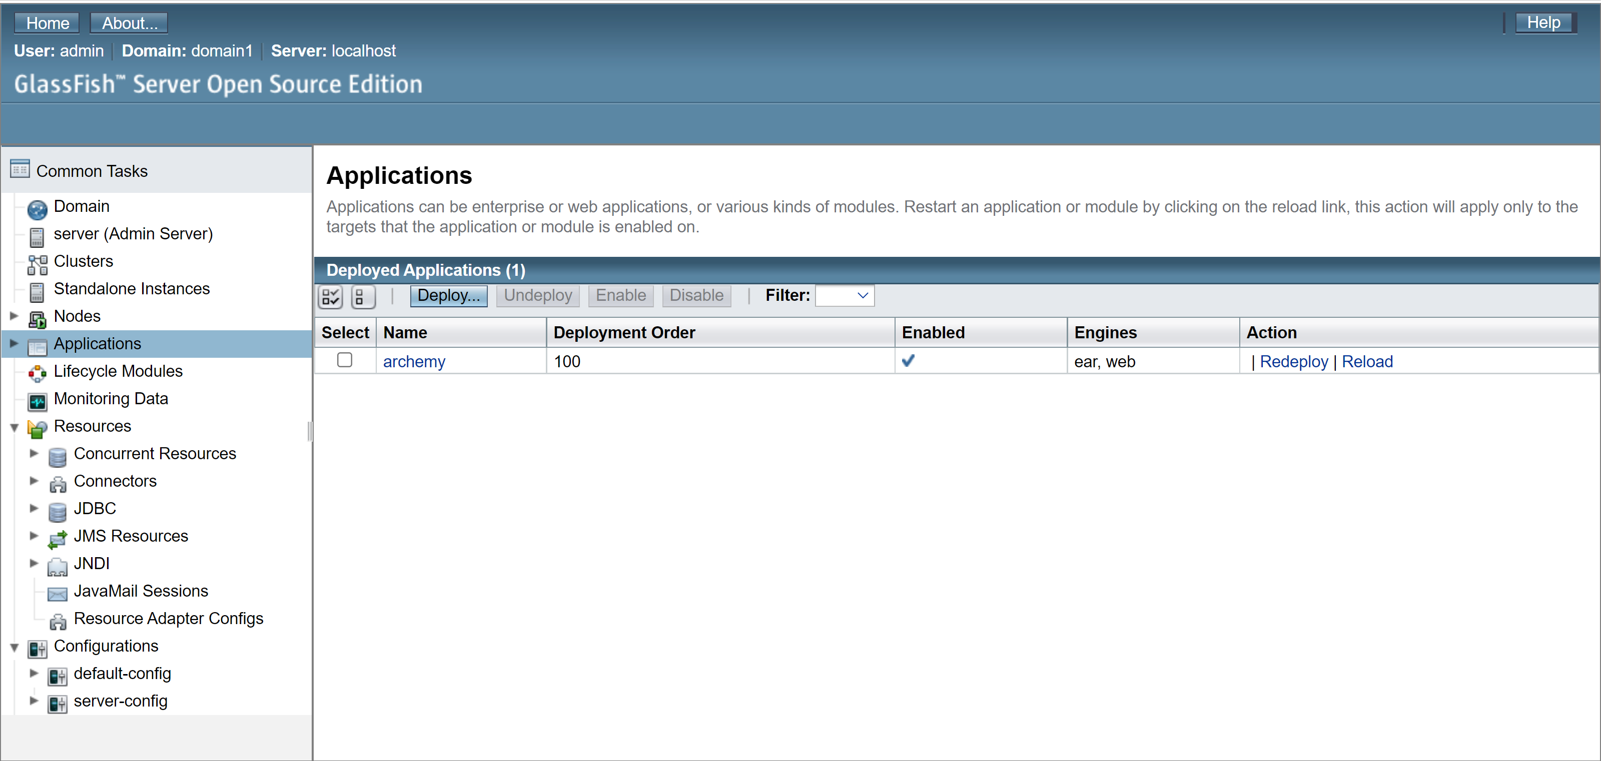

To launch the ArchNav Application, go to url:

https://your-ip-address:9999/archemy/faces/login.jspx